**ABOUT THE PROJECT**

The Project “COLLEGE MANAGEMENT SYSTEM” is an automated version of manual Student Management System. Itcan handle all details about the student. The details include college details, subject details, student personnel details, academic details, fee details, library details, etc…

In case of manual-system they need a lot of time, man power, etc… Here almost all work is computerised. So, the accuracy is maintained. Maintaining backup is very easy. It can do within a few minutes. Our system has only one accessing mode i.e. Administrator. College Management System is managed by an administrator. It is the job of the administrator to insert, update and monitor the whole process.

The main modules involved in this project are:

1. Login Form
2. Menu
3. Student Profile
4. Fee Receipt
5. Marksheet
6. Library Management

* **MODULE-WISE DESCRIPTION:**

1. **Login Form**–Login module is used to check whether the user is an authorised person to use the system or not. For this the user should give the correct username and password. There is an existing username and password in our project. It includes three buttons i.e. login, reset, exit. Exit and login button also generates message box which confirms the desired operation.
2. **Menu** – Menu module is used to give options for opening a particular interconnected module. It also consists of exit button which redirects the administrator to the login module. It can direct the administrator to the following modules: Student Profile, Fee Management, Marksheet, Library Management.
3. **Student profile**– Student Profile module is designed to add details of a student to the database. We can insert, view, reset, update or delete any particular detail of a student. The data entered into the database can be viewed with the help of a list-box.
4. **Fee Receipt** – Fee Receipt module is used to enter the students fee details. We can insert, view, update or delete any particular fee detail of a student. We can view the data using list-box.
5. **Marksheet** – Marksheet module is designed for submitting the semester marks of the students for a particular course of an individual student. It includes following buttons: save, view, update, delete.
6. **Library Management** – Library Management module is used for the data process of library and book accessing for students. It contains the book details as well as information regarding borrow and return date.We can insert, view, reset, update or delete any particular library detail of a student.

The modules i.e. student profile, fee management, marksheet, library management include exit button which redirects the administrator to the menu module which further redirects the administrator to login module using exit button.

* **FUTURE ENHANCEMENTS:**

This project works only for administrator and has modules for student profile, fee management, marksheet and library management. It can include modules for attendance, faculty profile, accounts, etc... Further, the faculty can upload the videos of their lectures on this platform and students who had missed those classes can view those videos. It can also include online examination module to conduct online examination. We can also introduce Students login module so that the student can view personal information as well as academic details more efficiently.

**ENVIRONMENT NECESSARY TO RUN THE PROJECT**

* **HARDWARE REQUIRED**
  + - * **PROCESSOR –**Intel core I3
      * **RAM –** 512 MBminimum, 1 GB recommended
      * **HARD DISK SPACE –** 1 GB minimum,
* **SOFTWARE REQUIRED**
* **OPERATING SYSTEM –**Windows 7 or later, macOS, Linux
* **EDITOR –**Python* versions 2.7.X, 3.6.X, 3.7.3
* **DATABASE –**SQLite

**FRONTEND**

Python is an interpreted, high level, general-purpose programming language. It is created by **Guido Van Rossum** and was first released in **1991.** Python was conceived in the late 1980s by Guido Van Rossum at **Centrum Wiskunde& Informatica**

(CWI) in the Netherlands as a successor to the ABC language, capable of exception handling and interfacing with the Amoeba Operating System.

Python is a multi-paradigm, object-oriented and structured programming language.

* **FEATURES OF PYTHON:**
* **Easy to Learn and Use** - Python is easy to learn and use. It is developer-friendly and high-level programming language.
* **GUI Programming Support**- Graphical user interfaces can be developed using Python.
* **Expressive Language**- Python language is more expressive means that it is more understandable and readable.
* **Interpreted Language**- Python is an interpreted language i.e. interpreter executes the code line by line at a time. This makes debugging easy and thus suitable for beginners.
* **Cross-platform Language**- Python can run equally on different platforms such as Windows, Linux, Unix and Macintosh etc. So,we can say that Python is a portable language
* **Object-Oriented Language** - Python supports object- oriented language and concepts of classes and objects come into existence
* **ADVANTAGES OF PYTHON:**
* **Easy to code and read–**Python is very easy to code as compared to other popular languages like JAVA and C++.
* **Free and open source** – Python is freely available. You can download it from the following link:

https://www.python.org

* **Large standard Library** – Python provides a large standard library which include areas like internet protocols, string operations, web services tools and Operating System interface.
* **Portable, Extensible and Embeddable** – Python can be extended to other languages like C++ or C. It is Embeddable as we can put our python code in the source code of a different language like C++.
* **DISADVANTAGES OF PYTHON:**
* **Speed Limitations -** Python has a slow speed of execution as it works with an interpreter, not the compiler.
* **Runtime Error -** Another disadvantage Python has is the runtime error. The programmer has the possibility to see the bugs only during runtime.
* **Design Restrictions -** The language has a lot of design limits and needs more testing time.
* **Memory Consumption -** Python has high memory consumption.
* **Weak in Mobile and Game computing** - The language is less suitable for mobile development and game development.

**BACKEND**

SQLite is embedded relational database management system. It is self-contained, serverless, zero configuration and transactional SQL database engine.

SQLite is free to use for any purpose commercial or private. In other words, "SQLite is an open source, zero-configuration, self-contained, stand alone, transaction relational database engine designed to be embedded into an application".

SQLite is different from other SQL databases because unlike most other SQL databases, SQLite does not have a separate server process. It reads and writes directly to ordinary disk files. A complete SQL database with multiple tables, indices, triggers, and views, is contained in a single disk file.

* **FEATURESOF SQLite:**
* **SQLite is totally free -**SQLite is open-source. So, no license is required to work with it.
* **SQLite is serverless -**SQLite doesn't require a different server process or system to operate.
* **SQLite is very flexible -** It facilitates you to work on multiple databases on the same session on the same time.
* **SQLite is a cross-platform DBMS-**You don't need a large range of different platforms like Windows, Mac OS, Linux, and Unix. It can also be used on a lot of embedded operating systems like Symbian, and Windows CE.
* **Storing data is easy-** SQLite provides an efficient way to store data.
* **Variable length of columns -**The length of the columns is variable and is not fixed.
* **SQLite** is written in **ANSI-C** and provides simple and easy-to-use API.
* **ADVANTAGES OF SQLite:**

SQLite is a very popular database which has been successfully used with on disk file format for desktop applications like version control systems, financial analysis tools, media cataloging and editing suites, CAD packages, record keeping programs etc.

There are a lot of advantages to use SQLite as an application file format:

### **1) Lightweight -**

* SQLite is a very light weighted database so, it is easy to use it as an embedded software with devices like televisions, Mobile phones, cameras, home electronic devices, etc.

### **2) Better Performance -**

* Reading and writing operations are very fast for SQLite database. It is almost 35% faster than File system.
* It only loads the data which is needed, rather than reading the entire file and hold it in memory.

### **3) No Installation Needed-**

* SQLite is very easy to learn. You don’t need to install and configure it. Just download SQLite libraries in your computer and it is ready for creating the database.

### **4) Reliable -**

* It updates your content continuously so, little or no work is lost in a case of power failure or crash.
* SQLite is less bugs prone rather than custom written file I/O codes.

### **5) Portable -**

* SQLite is portable across all 32-bit and 64-bit operating systems and big- and little-endian architectures.

### **6) Accessible -**

* SQLite database is accessible through a wide variety of third-party tools.
* SQLite database's content is more likely to be recoverable if it has been lost. Data lives longer than code.

### **7) Reduce Cost and Complexity -**

* It reduces application cost because content can be accessed and updated using concise SQL queries instead of lengthy and error-prone procedural queries.
* SQLite can be easily extended in in future releases just by adding new tables and/or columns.
* **DISADVANTAGES OF SQLite:**
* SQLite is used to handle low to medium traffic HTTP requests.
* Database size is restricted to 2GB in most cases.

**FLOWCHART OF**

**COLLEGE MANAGEMENT SYSTEM**

**FLOW DIAGRAM OF**

**COLLEGE MANAGEMENT SYSTEM**

**LOGIN**

**MENU**

**LIBRARY**

**MANAGEMENT**

**FEE**

**MANAGEMENT**

**STUDENT**

**PROFILE**

**MARKSHEET**

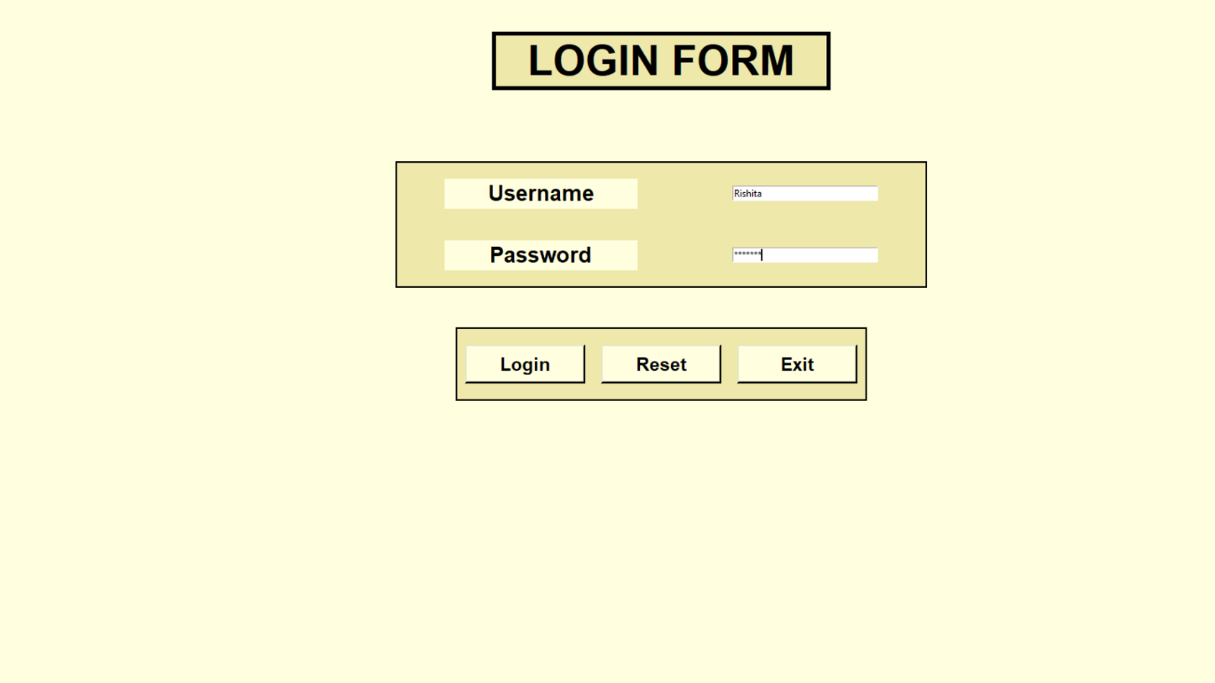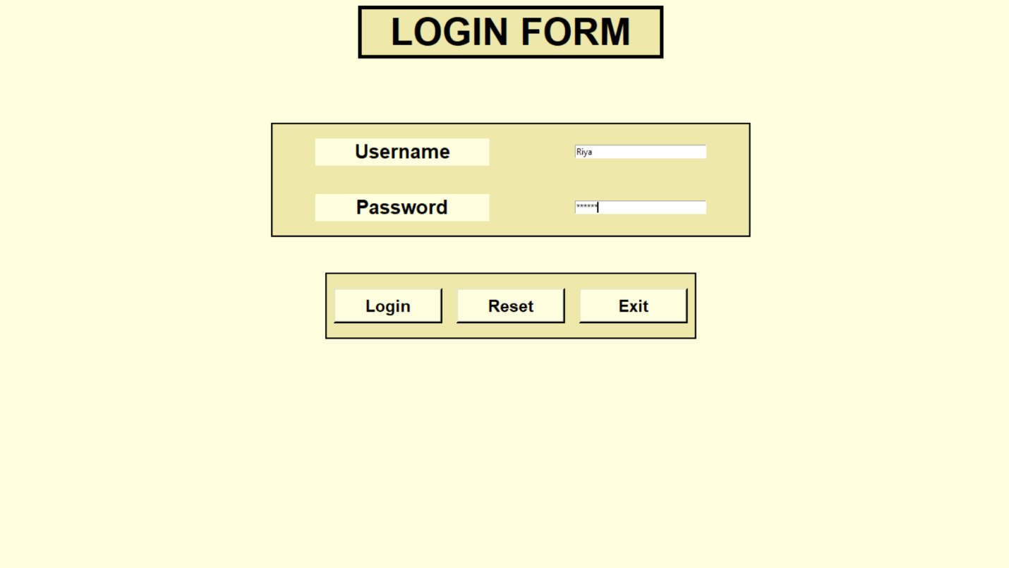**LOGIN FORM**

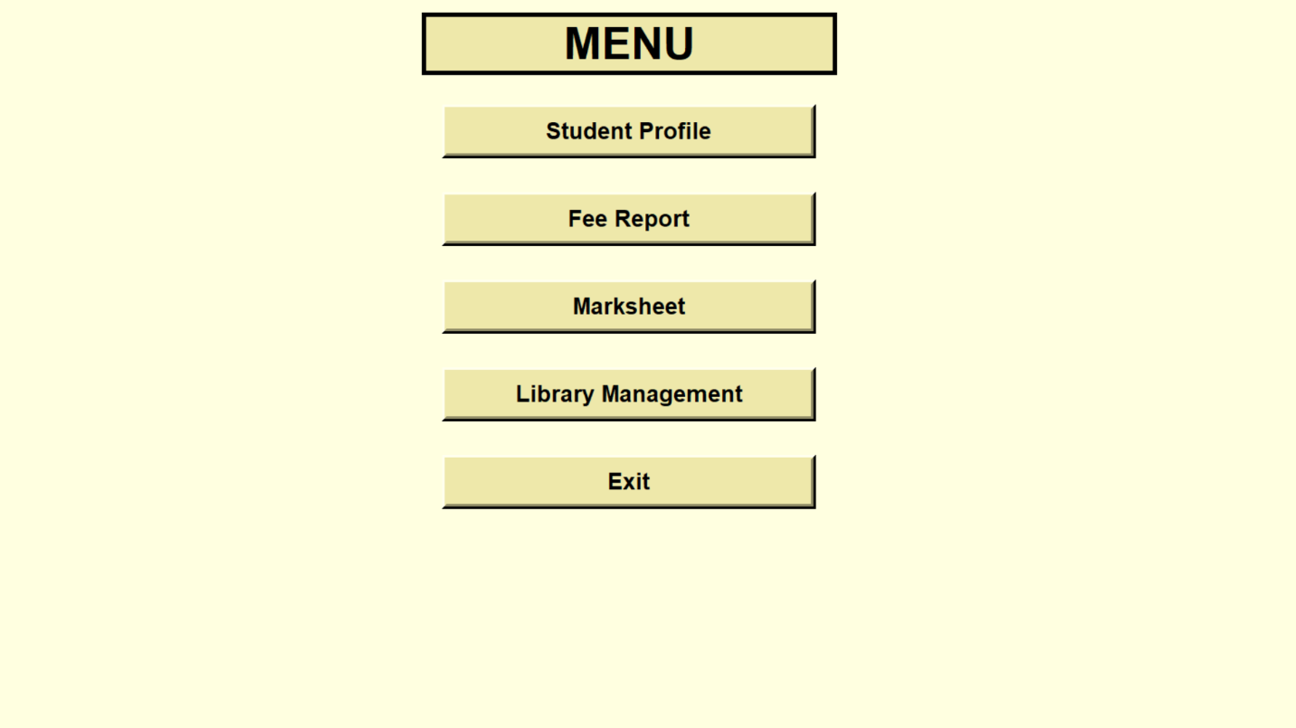**MENU**

**STUDENT PROFILE**

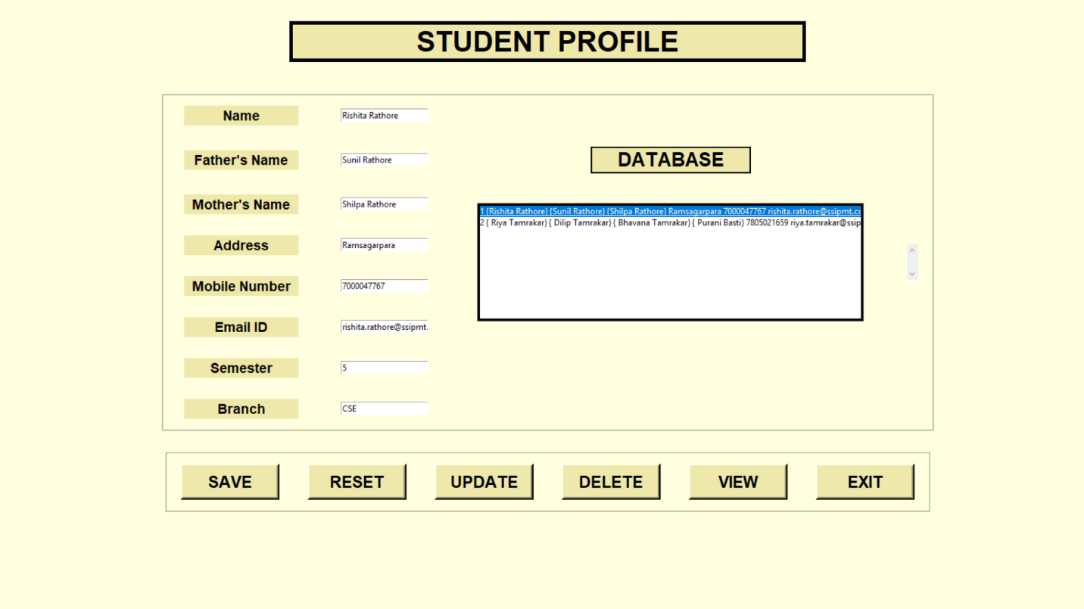

**FEE MANAGEMENT**

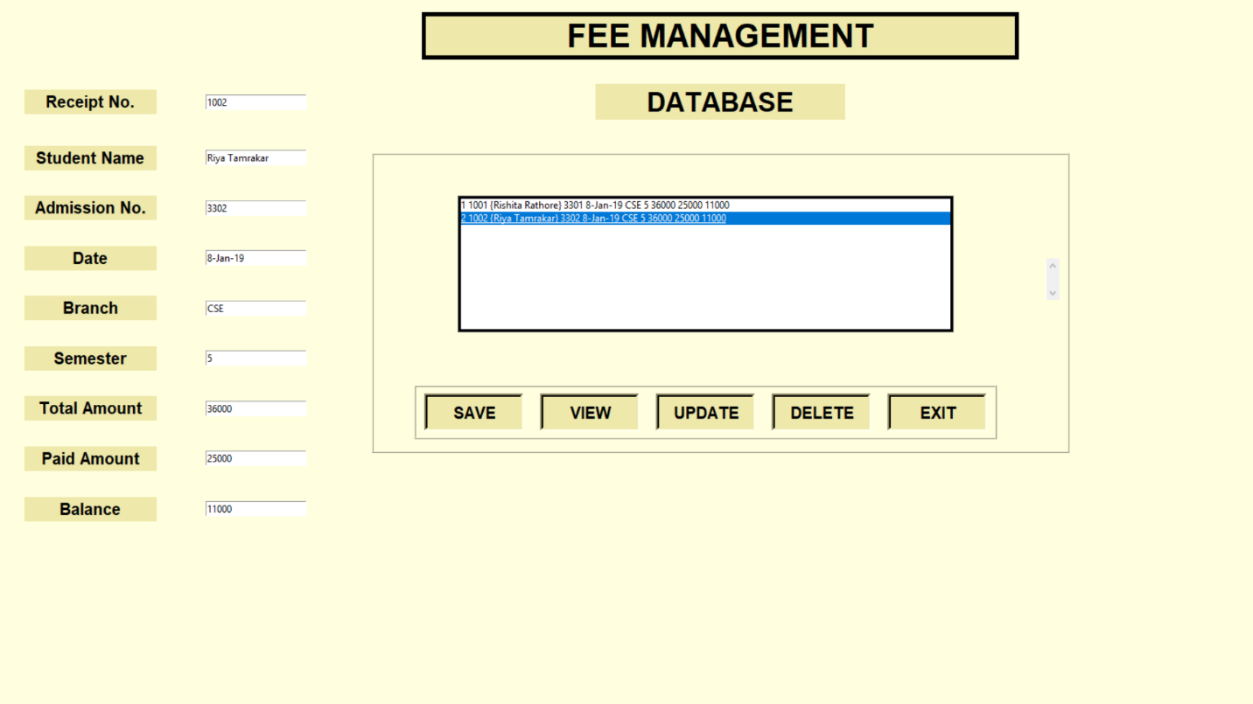

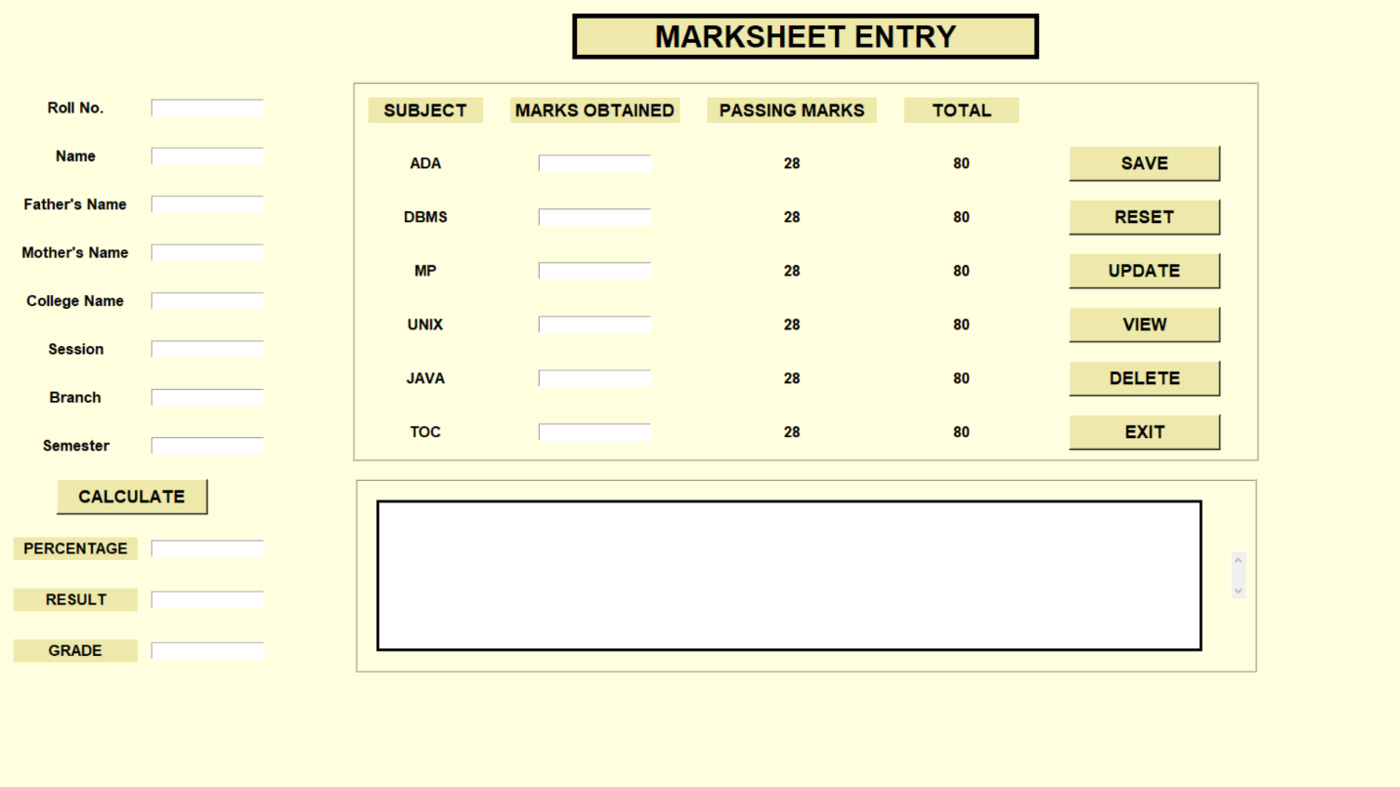**MARKSHEET**

**LIBRARY MANAGEMENT**

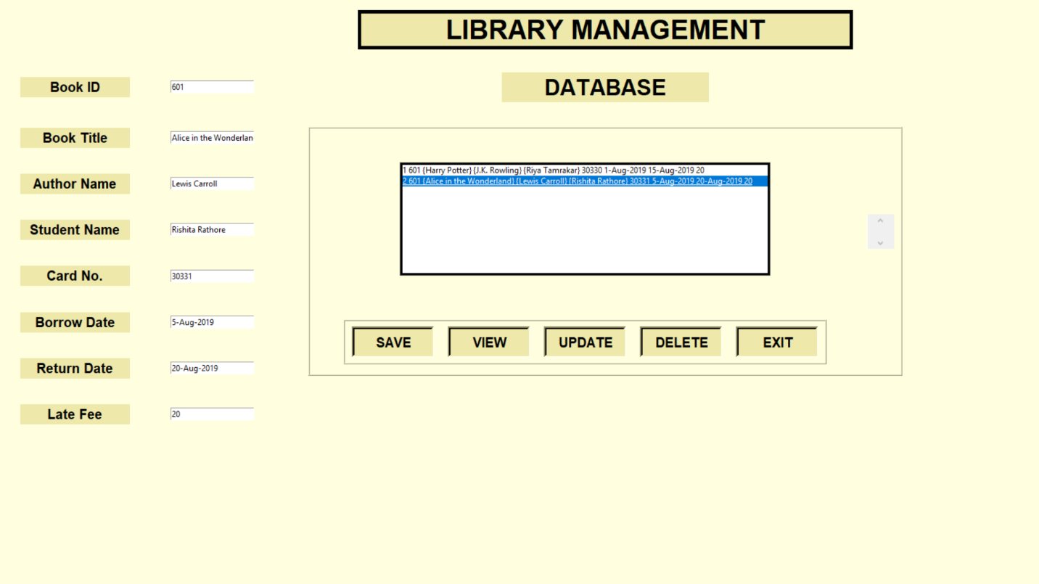

**PYTHON APPLICATIONS**

**1)Web Applications:**

We can use Python to develop web applications. It provides libraries to handle internet protocols such as HTML and XML, Email processing, request, etc… It also provides Frameworks such as Django, Pyramid, Flask etc to design and develop web-based applications. Some important developments are: PythonWikiEngines, PythonBlogSoftware etc.

**2)Desktop GUI Applications:**

Python provides Tk GUI library to develop user interface in python-based application. Some other useful toolkits wxWidgets, Kivy, pyqt that are useable on several platforms. The Kivy is popular for writing multitouch applications.

**3)Software Development:**

Python is helpful for software development process. It works as a support language and can be used for build control and management, testing etc.

**4)Scientific and Numeric:**

Python is popular and widely used in scientific and numeric computing. Some useful library and package are SciPy, Pandas etc. SciPy is group of packages of engineering, science and mathematics.

**5)Business Applications:**

Python is used to build Business applications like ERP and e-commerce systems. Tryton is a high-level application platform.

**6)Console Based Application:**

We can use Python to develop console-based applications. For example: **IPython**.

**7)Audio or Video based Applications:**

Python is awesome to perform multiple tasks and can be used to develop multimedia applications. Some of real applications are: TimPlayer, cplay etc.

**8) 3D CAD Applications:**

To create CAD application Fandango is a real application which provides full features of CAD.

**9) Enterprise Applications:**

Python can be used to create applications which can be used within an Enterprise or an Organization. Some real time applications are: OpenErp, Tryton, Picalo etc.

**10) Applications for Images:**

Using Python several applications can be developed for image. Applications developed are: VPython, Gogh, imgSeek etc.

There are several such applications which can be developed using Python

**REFERENCES**

* [**www.javatpoint.com**](http://www.javatpoint.com)
* [**www.wikipedia.org**](http://www.wikipedia.org)
* [**www.stackoverflow.com**](http://www.stackoverflow.com)